|  |  |
| --- | --- |
| Power BI Lab Day 7 Document | |
|  |  | | |
| **Writer:** | I&D Microsoft | | **Initials entity:** |
| **Date creation:** 04/05/2018 | |  | **Last upgrade:** 04/05/2018 |

Power BI LAB DOCUMENT

DAY 7- Lab 3

|  |  |  |  |  |
| --- | --- | --- | --- | --- |
| Version | Author | Comment | Reviewed By | Date |
| V 1.0 | I&D Microsoft | Initial draft | Moupiya Das |  |
|  |  |  |  |  |
|  |  |  |  |  |

**Pre-requisites**

1: Installed and working Power BI Desktop setup.

2: TV ratings Excel containing the data.

3: Pictures

**Environment Setup**

To install Power BI Desktop to your machine or to sign up for Power BI Service, Refer to Power BI Lab Exercise Day 1.

**Lab Overview**

To Create a data story.

**Case Scenario**

The Timeline Storyteller is a great way to tell a story about your data. It gives you the ability to create multiple representations of your data and then pull them together by creating multiple scenes. We are going to represent a story on TV shows spanning over last few decades.

# Table of Contents

Table of Contents 3

1. Import Data 4

2. Import and setting up visual 6

3. Create Story 9

# 1. Import Data

1. Start with a blank Power BI Desktop file.
2. Click on Get Data option in the ‘Home’ tab and select **‘Excel’** as the connection type.

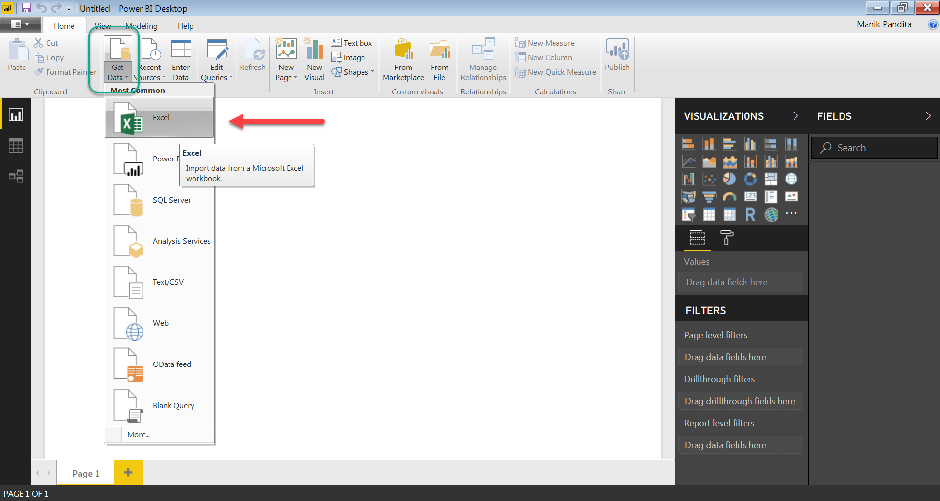

1. Select the **TV ratings** Excel which contains the data.

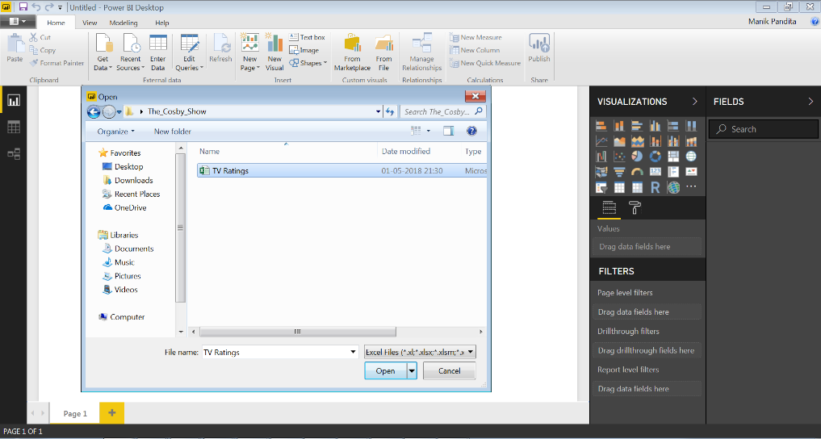

1. Once the TV Ratings Excel file has been selected, a pop up window containing the tabs present in Excel will open, select ‘**Show Ratings by Year**’ tab and click on **Load**.

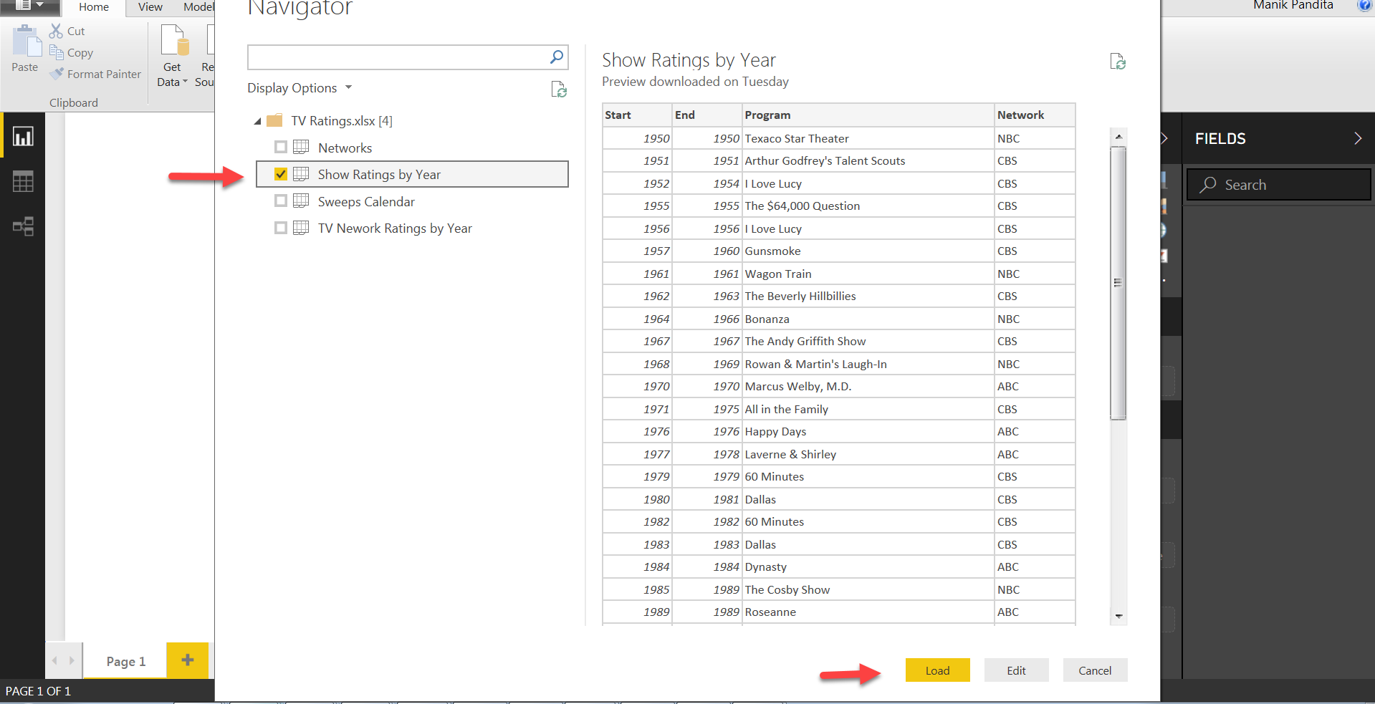

1. The file will be loaded in Power BI desktop as shown below.

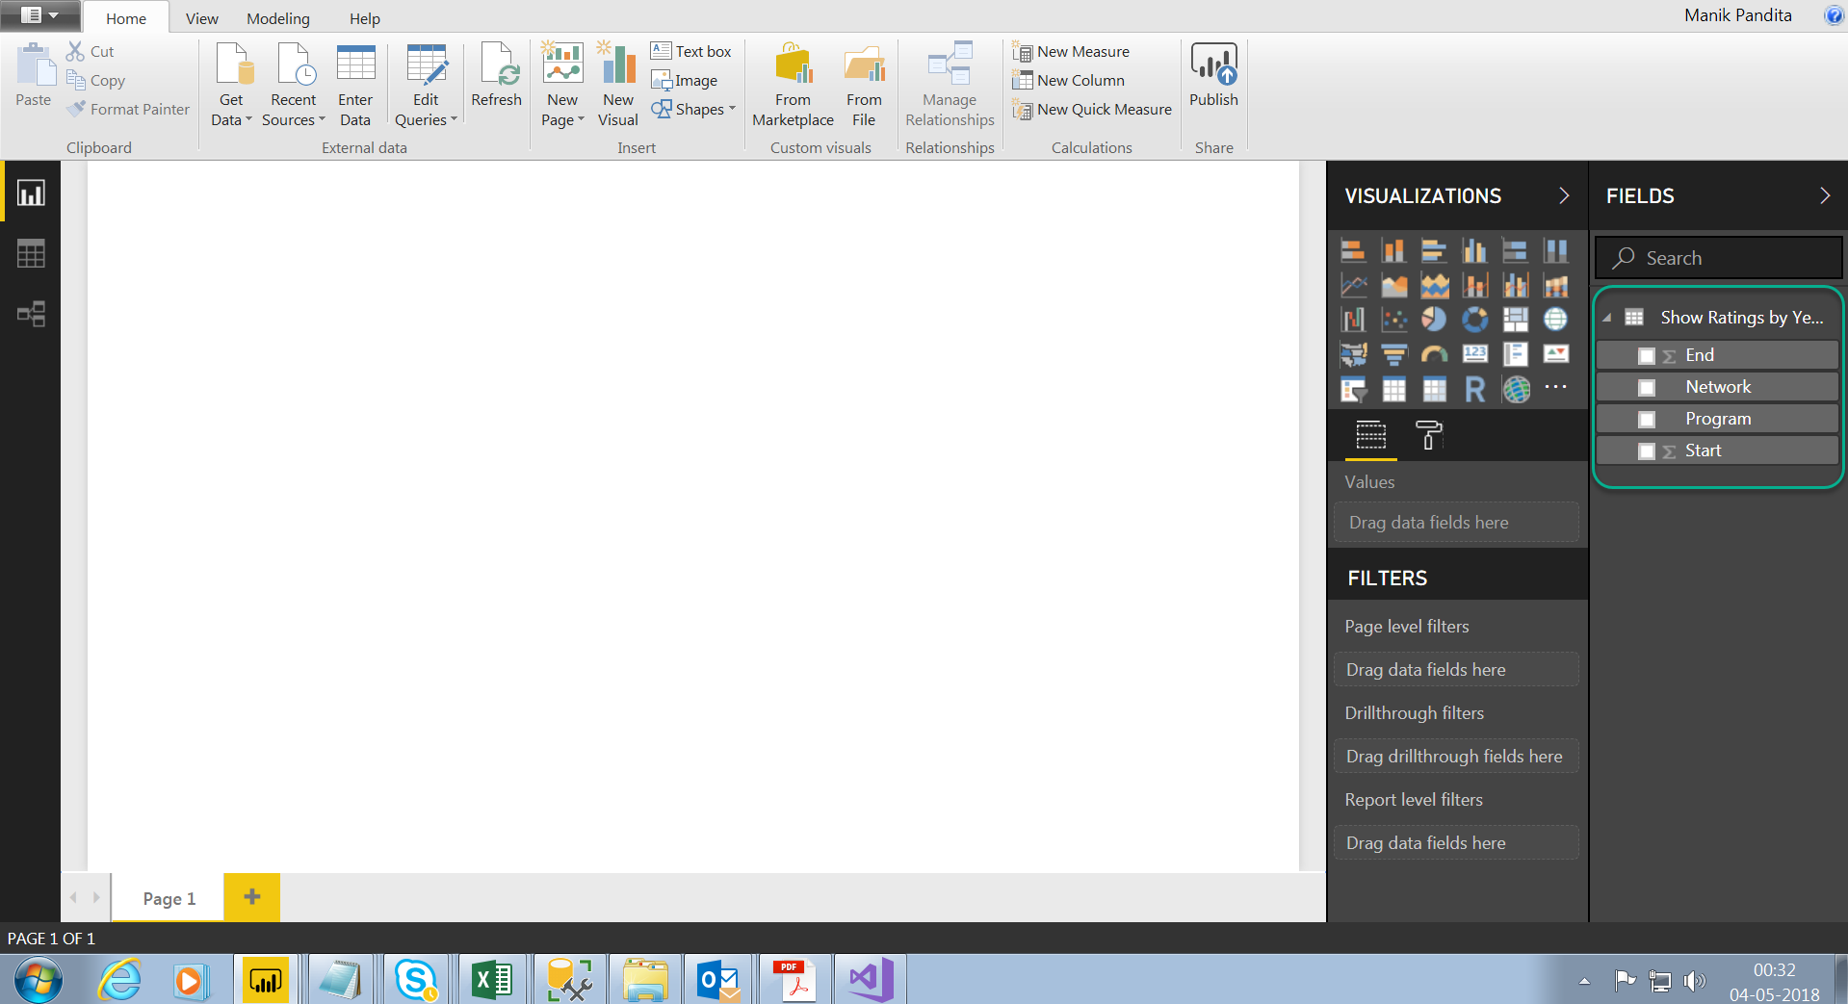

# 2. Import and setting up visual

1. Click on the ellipses (3 dots, shown below) which will open a small pop up box. Select **Import from Marketplace.**

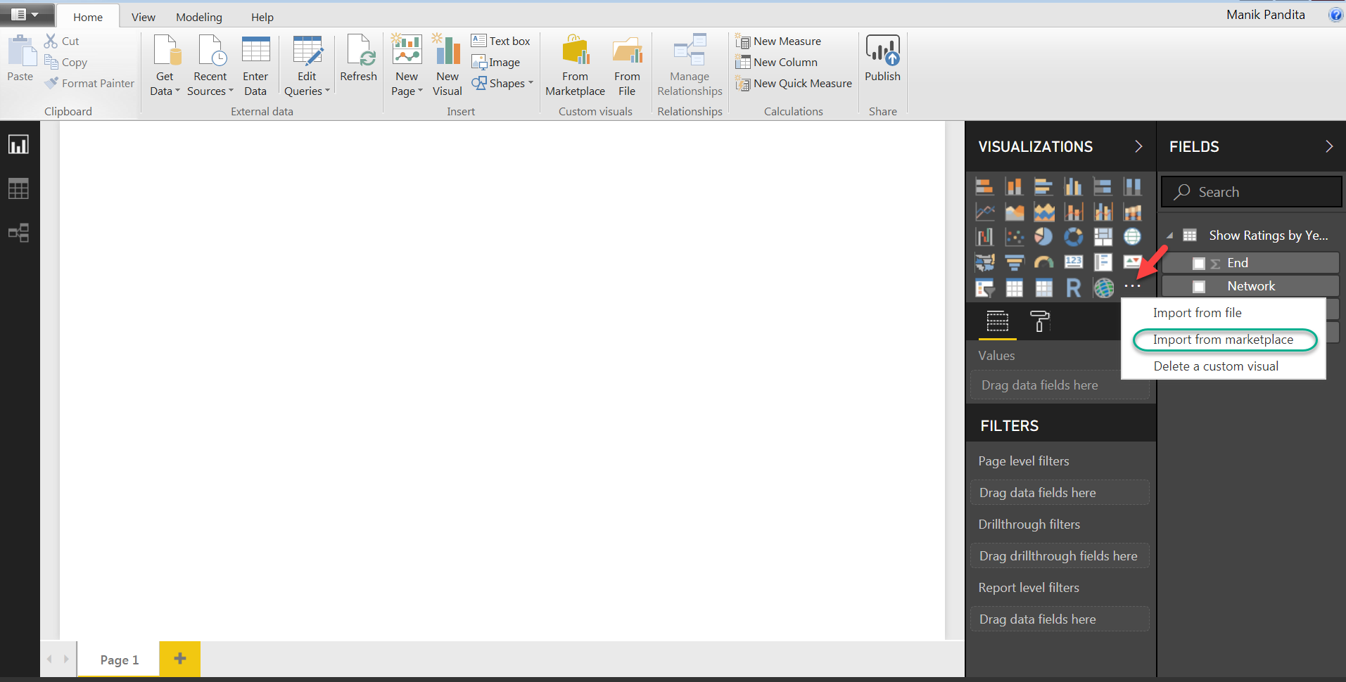

1. This will open the market place. In the search box type **Timeline Storyteller** and press enter to find the Visual as shown below. Once the visual is found click **Add**.

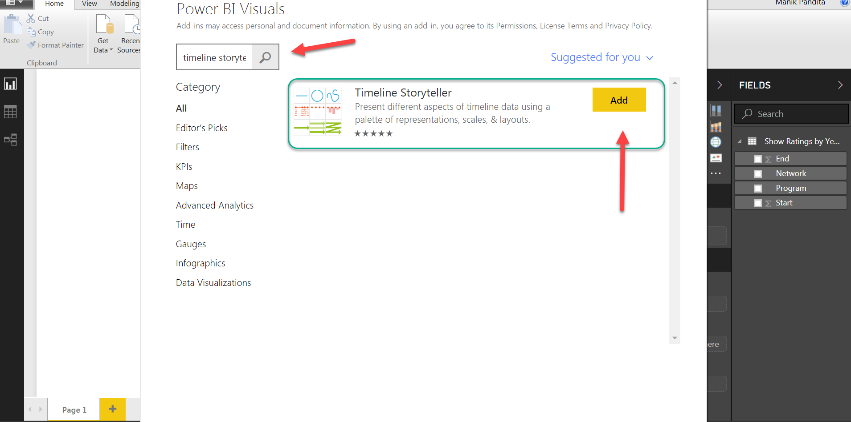

1. Once you have clicked on add, Custom visual will be added on under visualizations on the right side. Also, a Success message will be displayed on a dialog box as shown below.

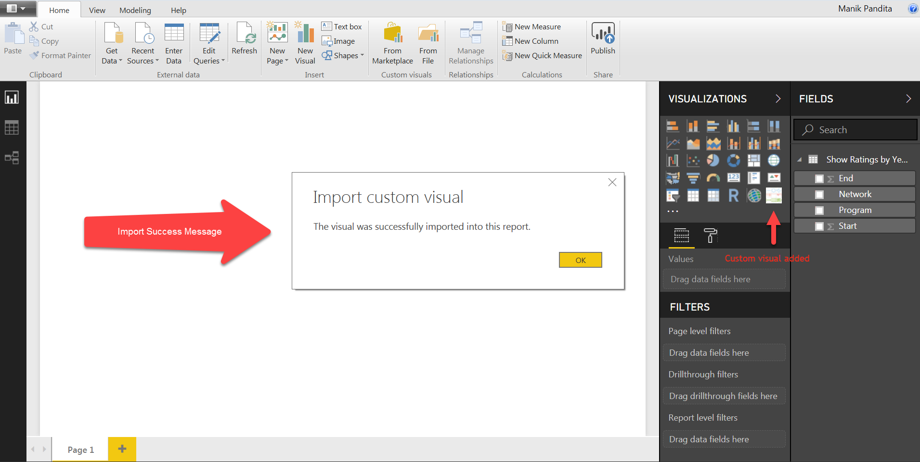

1. Click on the newly added custom in visualization space on the right side to get the visual on pane.

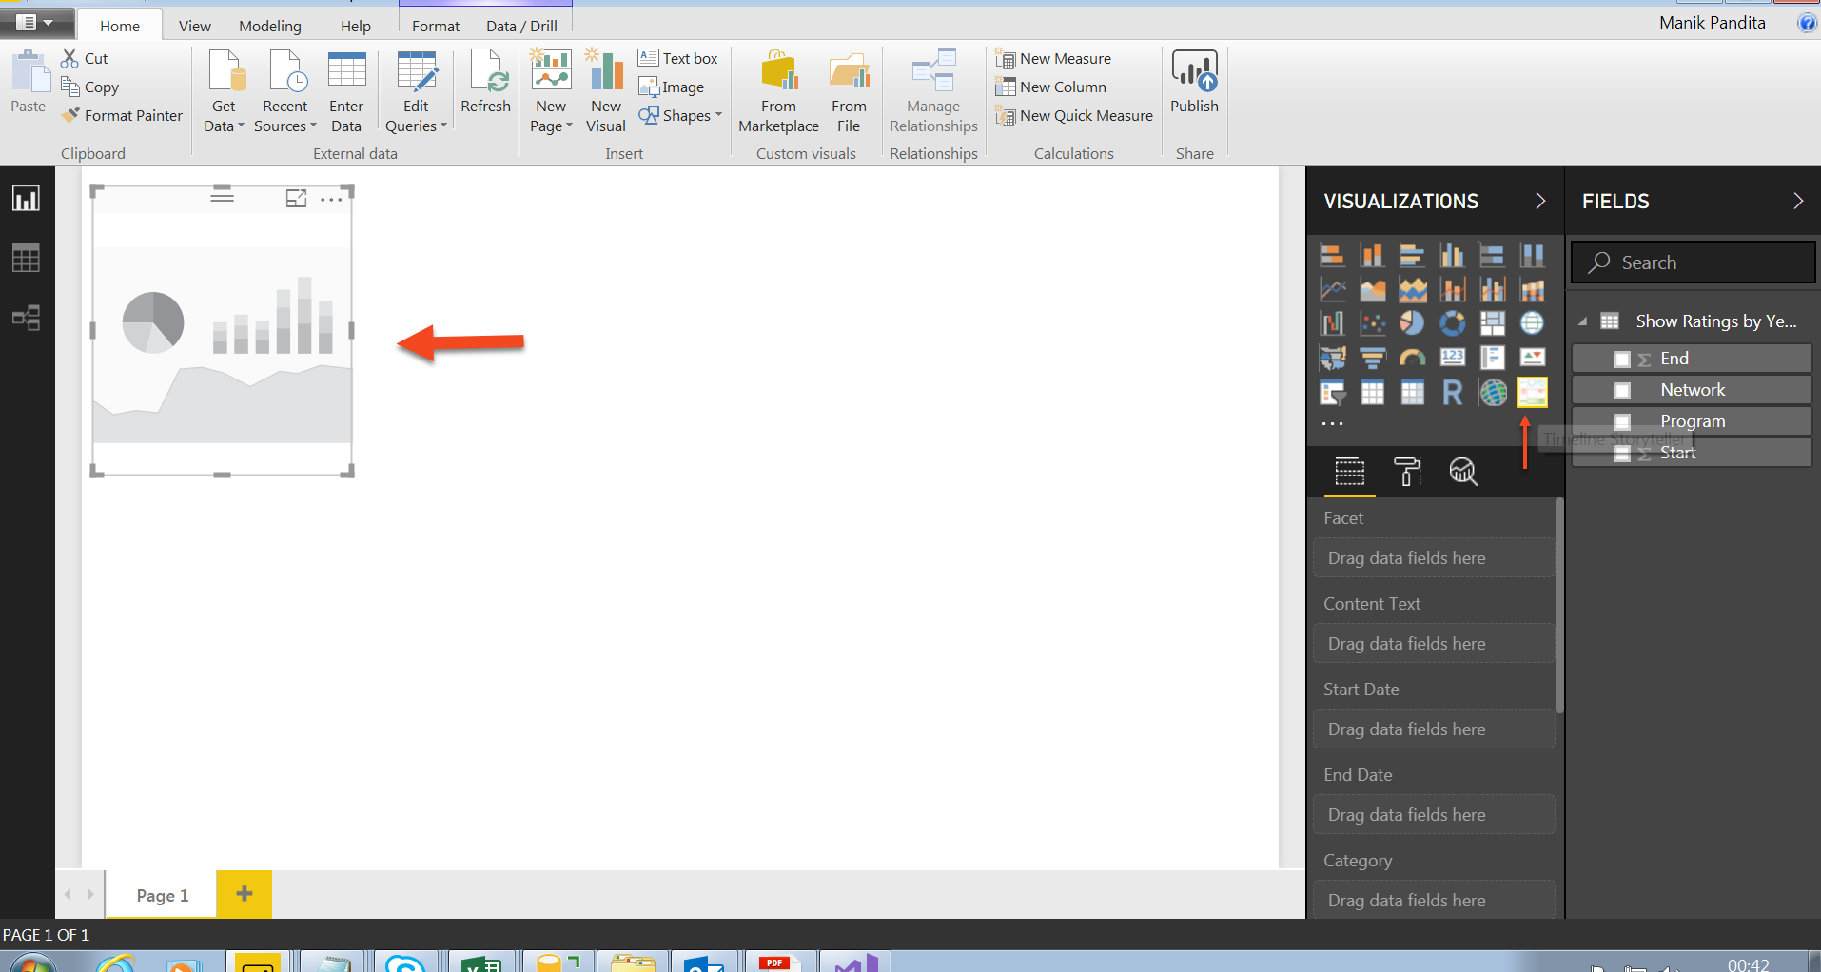

1. Adjust the Visual by using the hooks on the sides of the visuals.

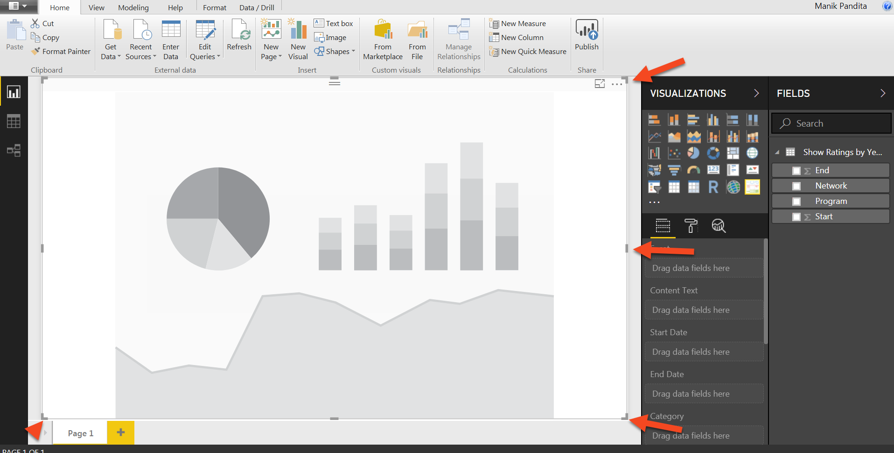

1. Drag and drop the columns as shown below.

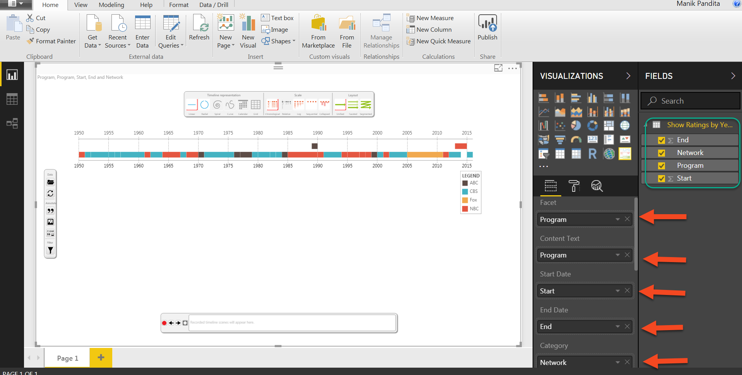

1. Adjust the UI Scale under display from 0.7 to 1. Also, enable the Auto load option as shown below.

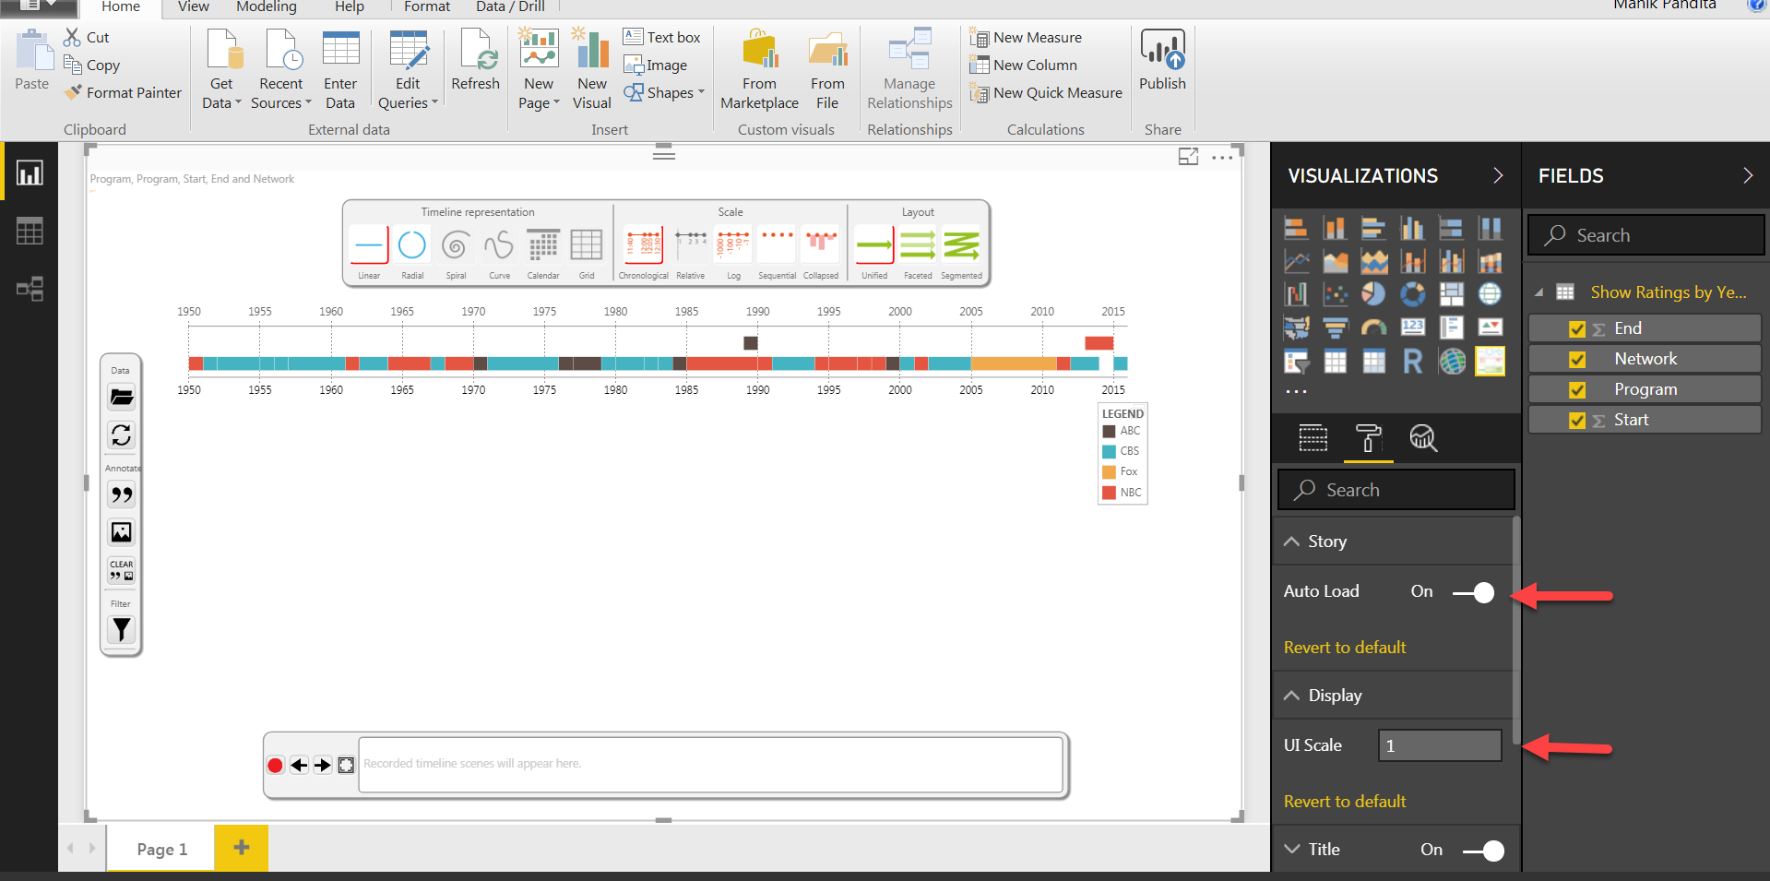

# 3. Create Story

1. Select the **Timeline representation** to **Linear**, **Scale** to **Chronological** and **Layout** to **Segmented** as shown below.

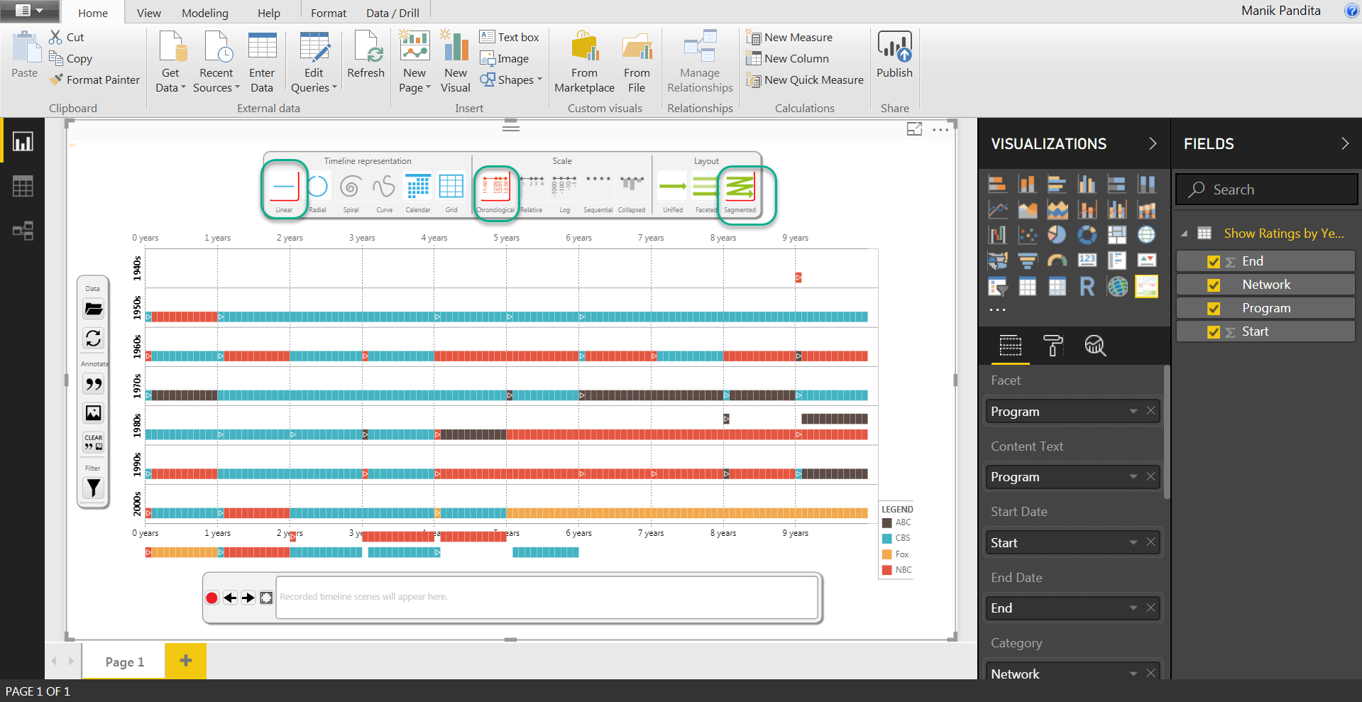

1. Click on the Reed Button to record the scene as shown below.

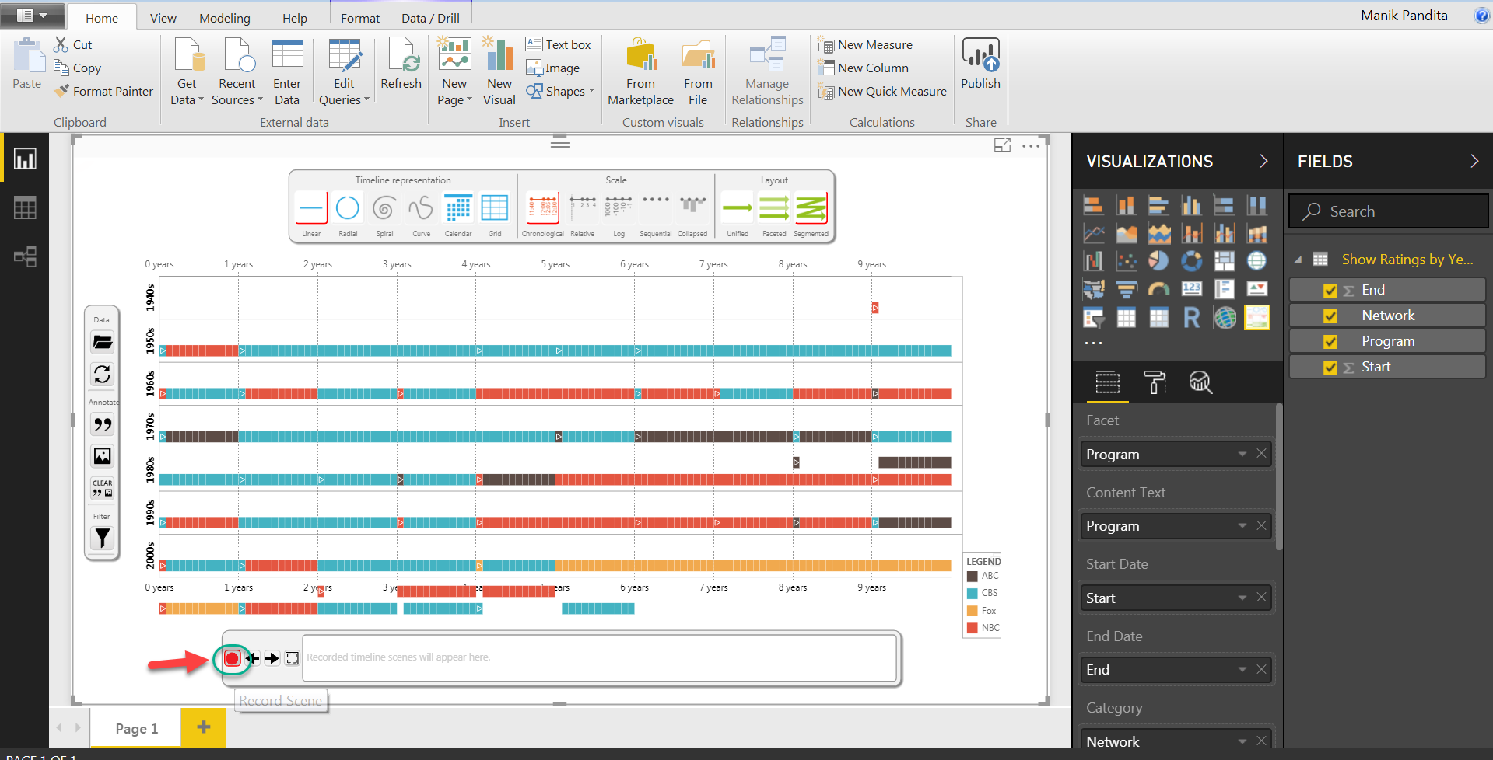

1. This will be used as the 1st scene of our data story.

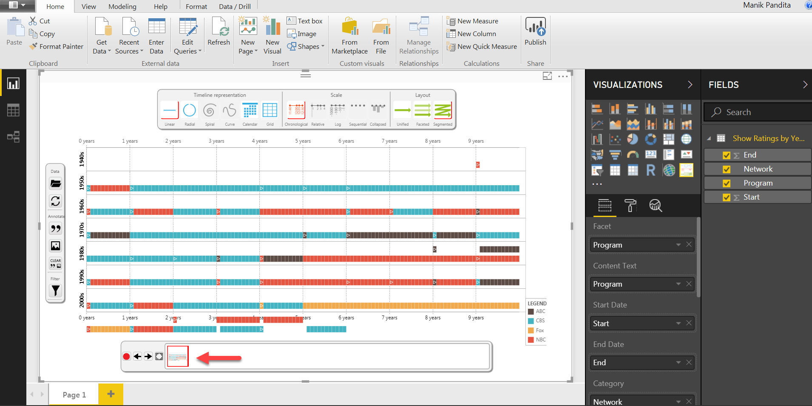

1. Click on the **Filter** Tab. Press Ctrl on keyboard and under Facet select **Roseanne** and **The Cosby Show** (Ctrl for multiple selection).

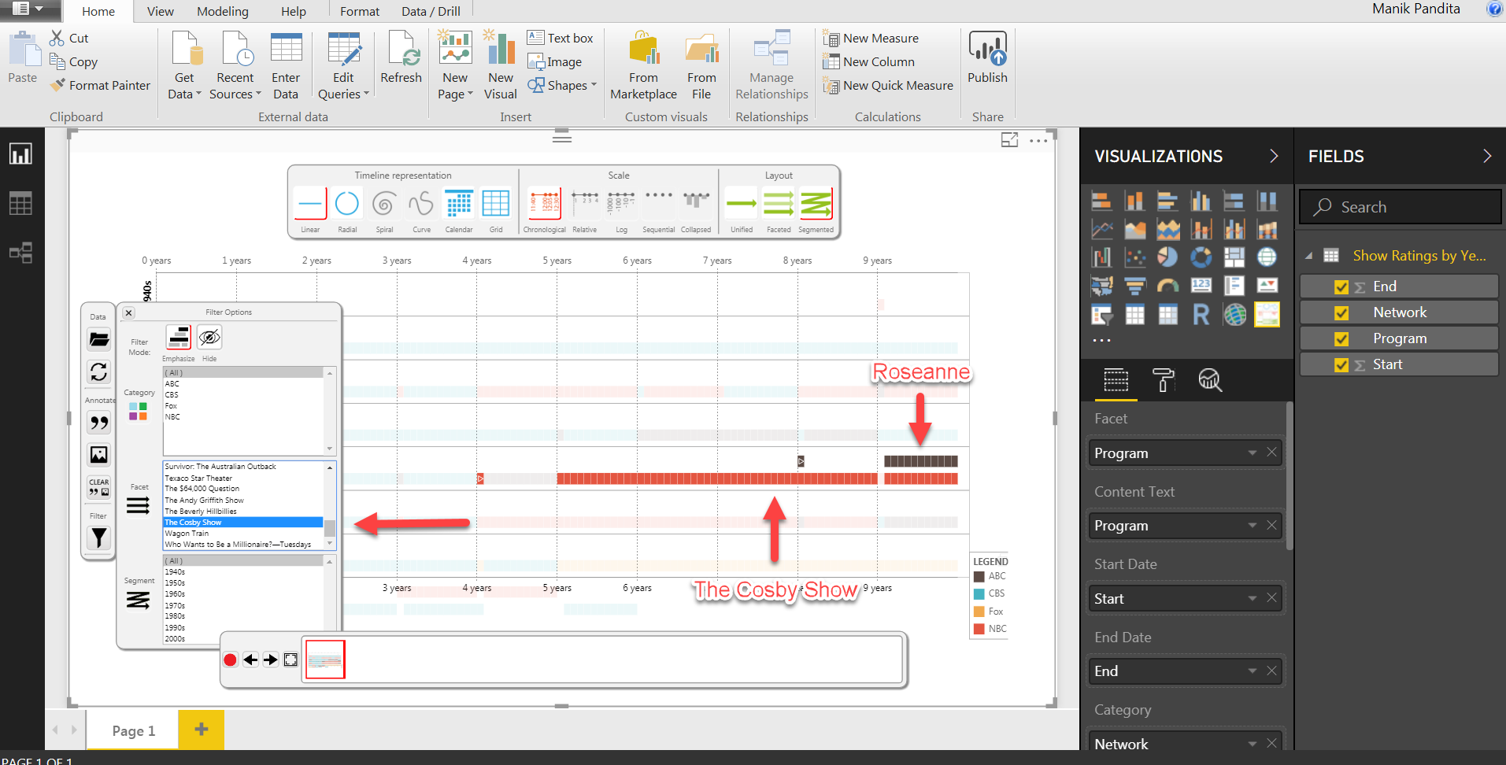

1. Click on the **Annotate** tab and enter the text as shown below. Once done click on Tick mark present on the right upper side of the text box.

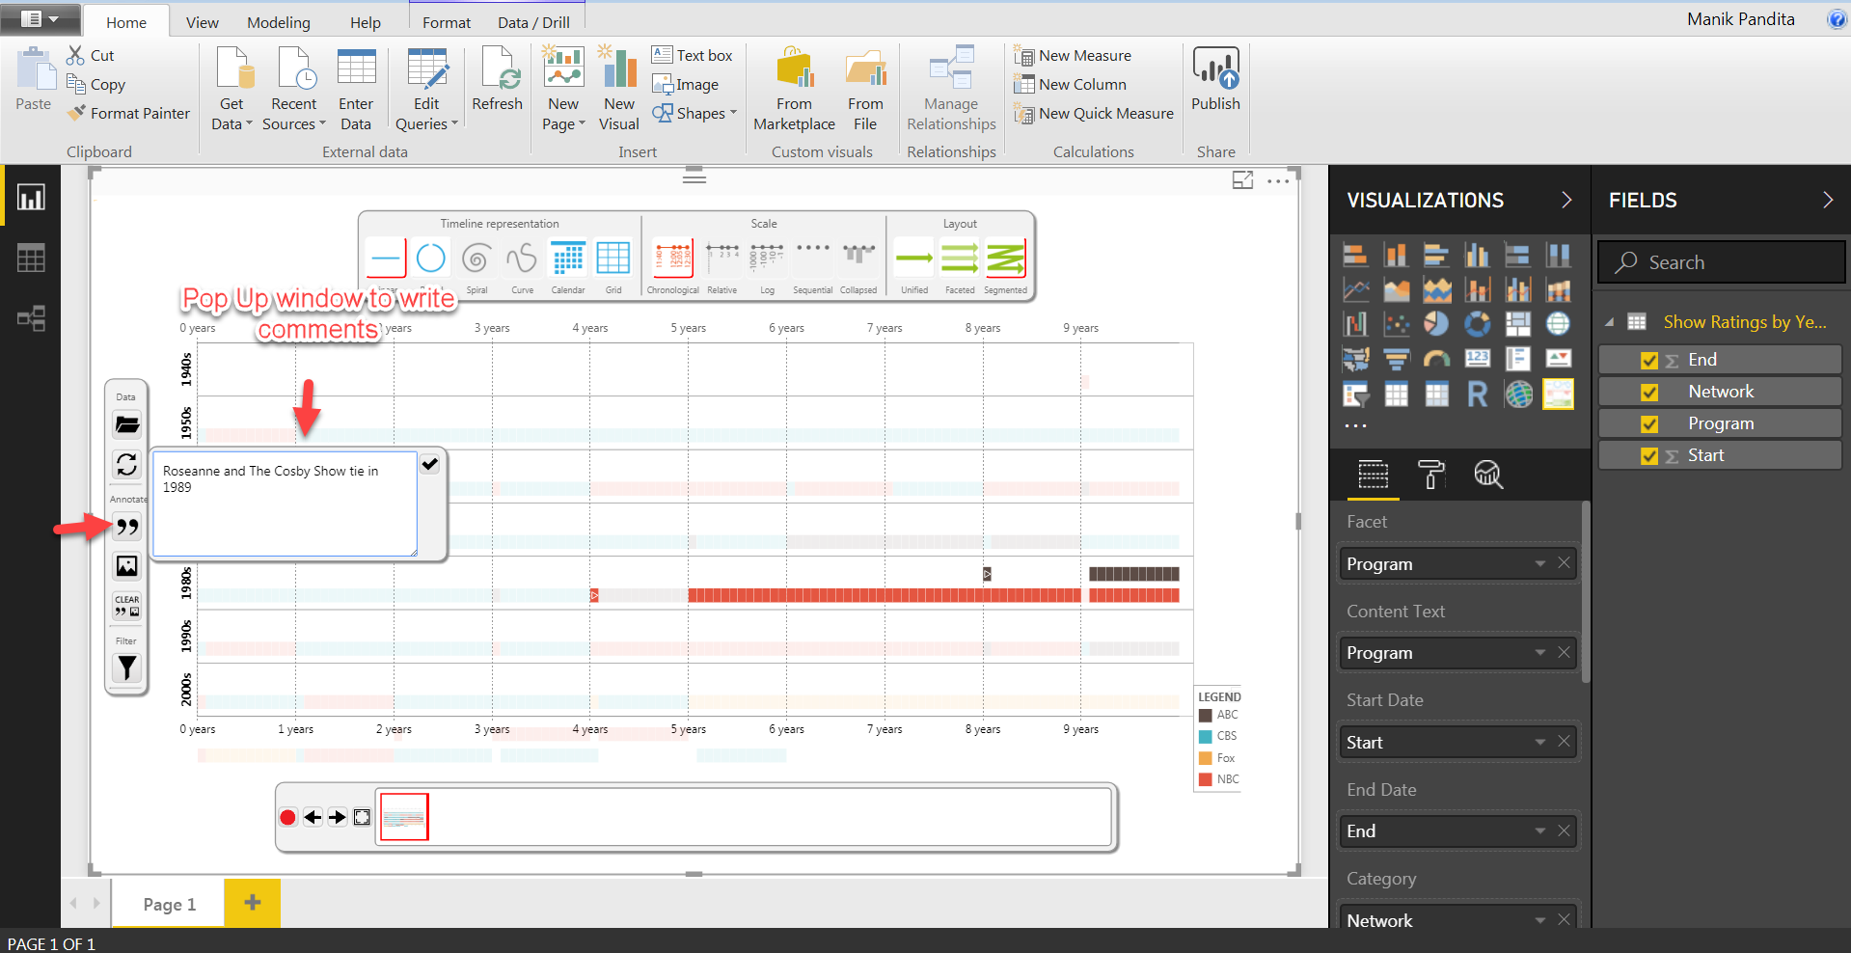

1. This will add the text and fields as shown below, record the scene by clicking on red button to create Scene 2

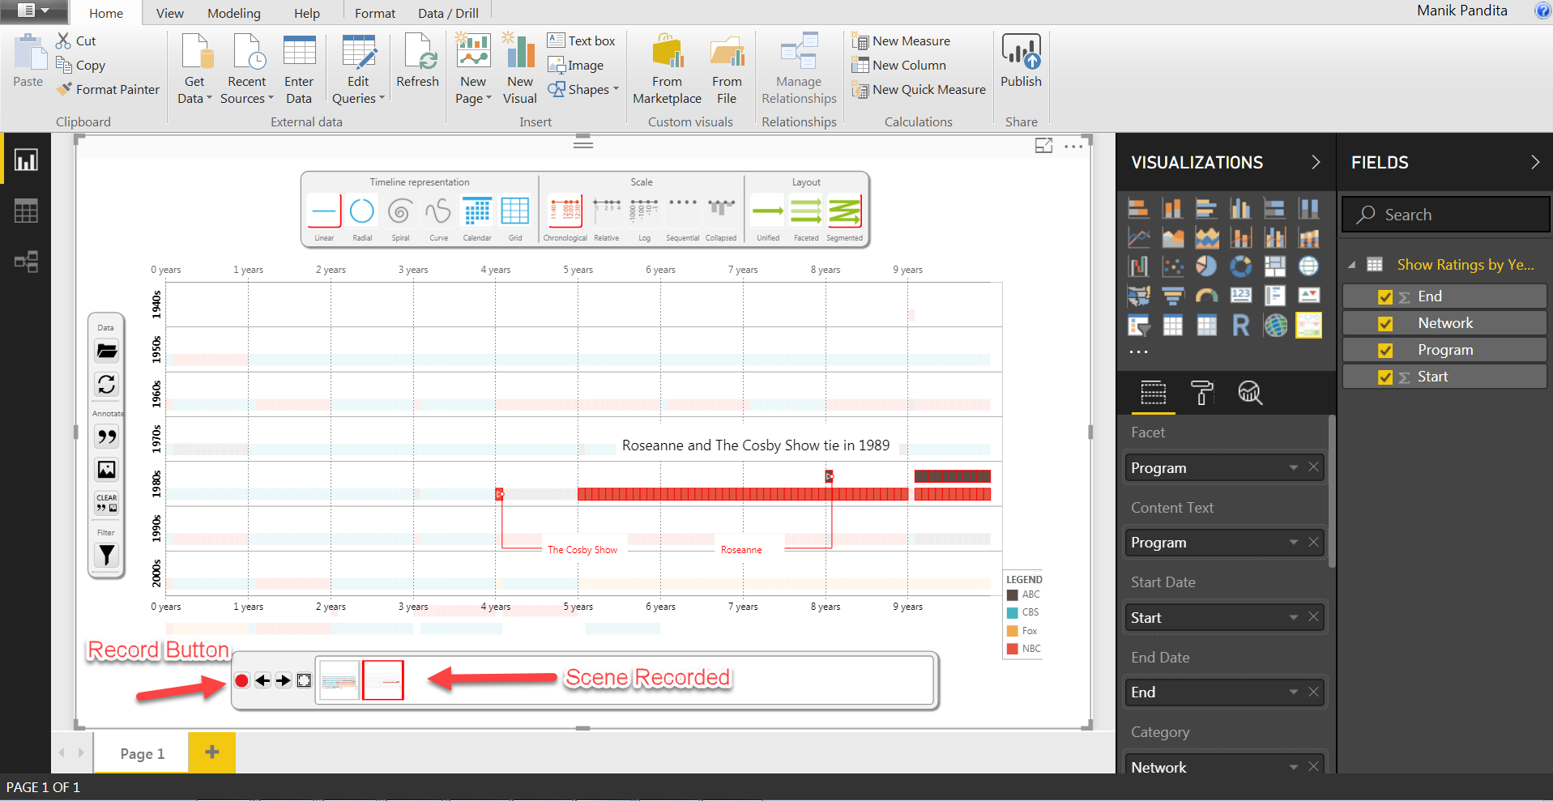

1. Click on **Clear** tab to remove annotate text and unselect the selected shows in facet.

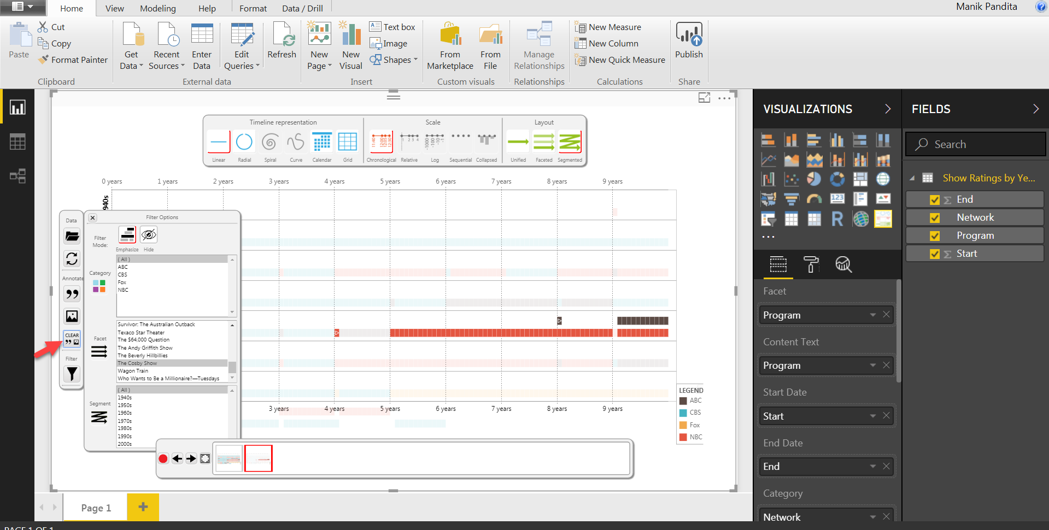

1. Repeat the above Steps (Step 4 to Step 6) to create Scene 3. Select NCIS and Sunday Night Football in facet under filter and annotate the text as shown below.

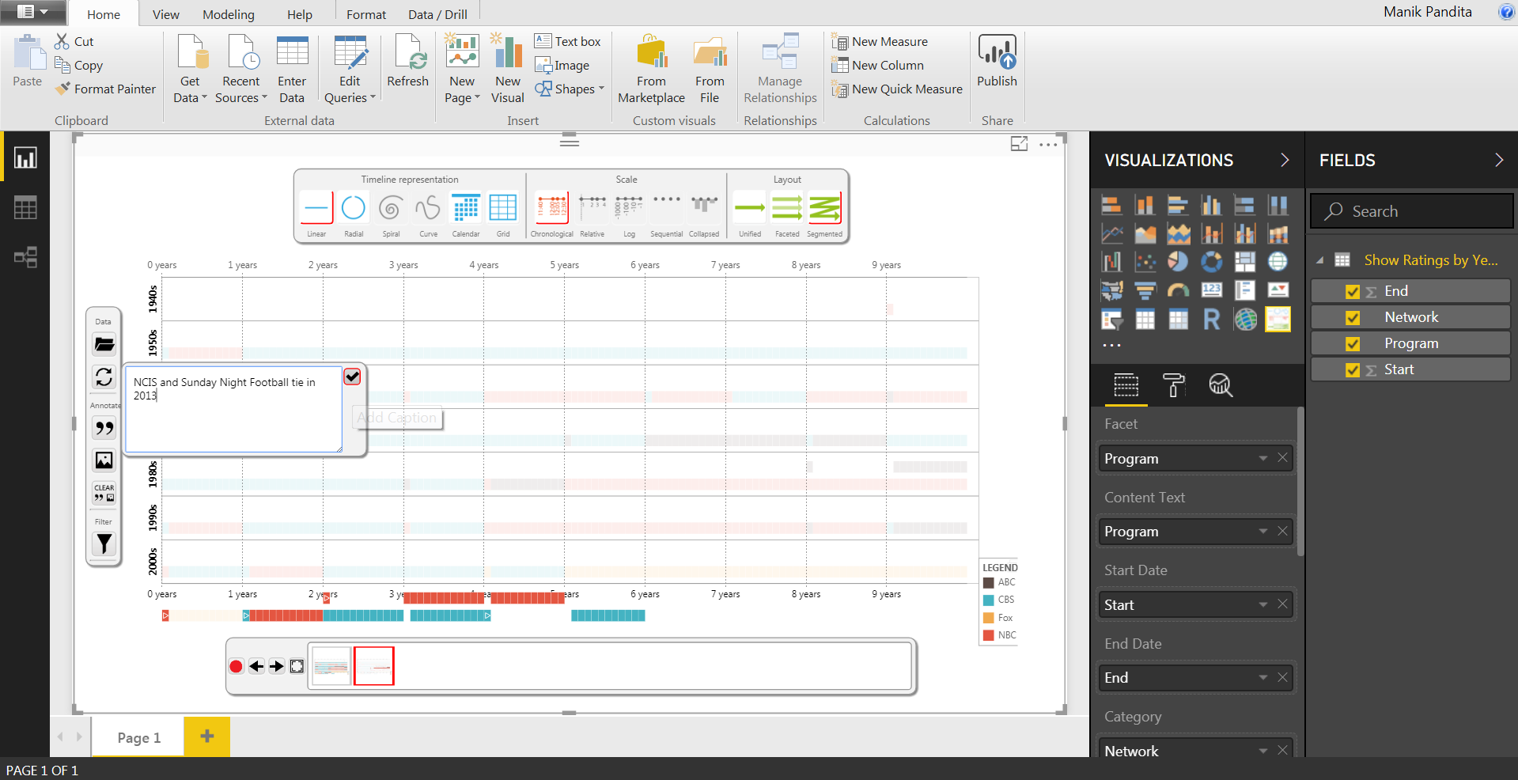

1. Once Done, the visual will look something like the below screenshot. Don’t forget to click on red button to record the Scene.

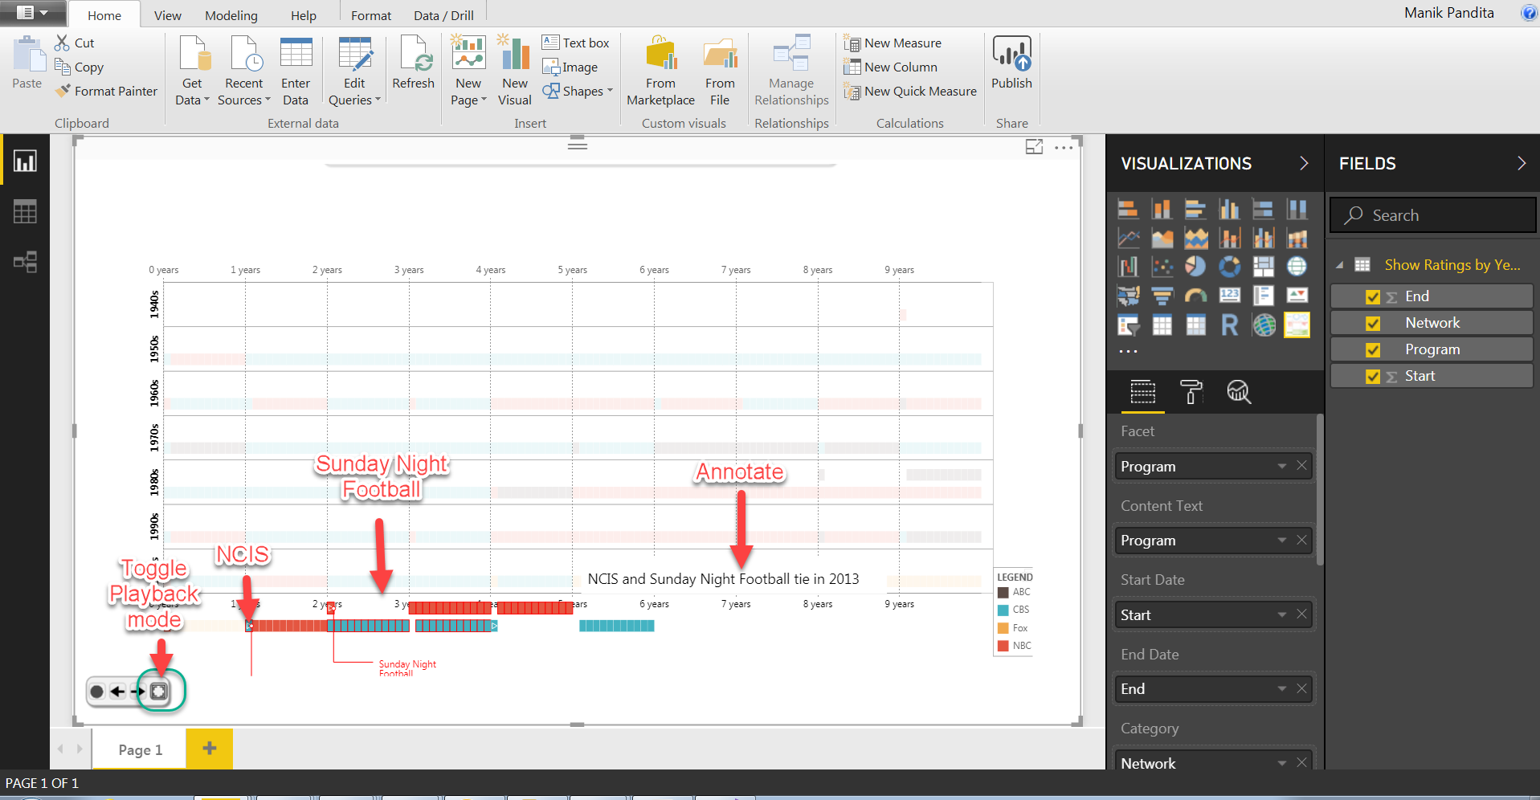

Toggle playback mode will minimize the controls for our ease.

1. Create Scene 4 by following the below mentioned points.

Click **clear** to remove any annotate text.

Select **All** in **Facets** under **Filter**

Select **Timeline Representation** as **Radial, Scale** as **Chronological and Layout** as **Unified**

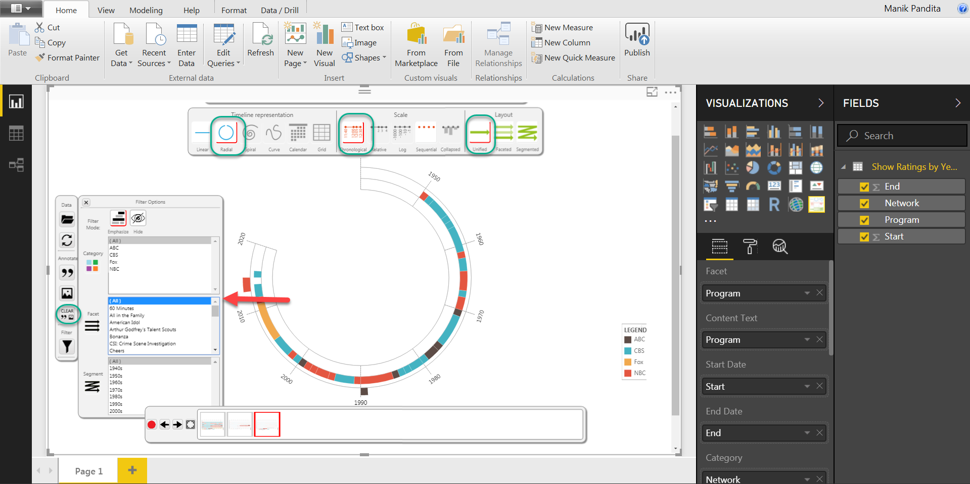

1. Click on Annotate text and enter the below text as shown in screenshot. Once done click on record scene to add this to recorded scene list.

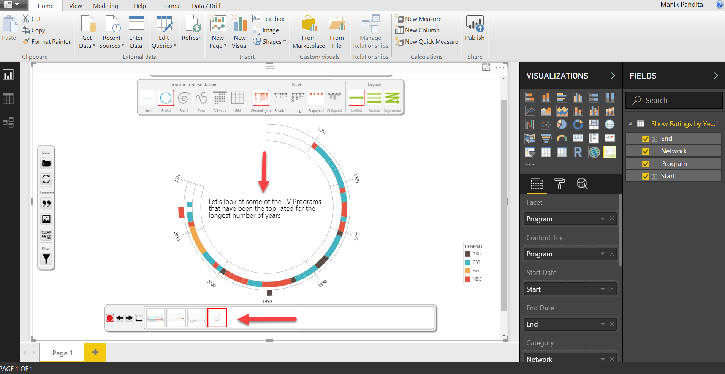

1. Once done, click on Clear again to remove text. Keeping the same settings, select I love Lucy show and annotate text as shown in the screenshot.

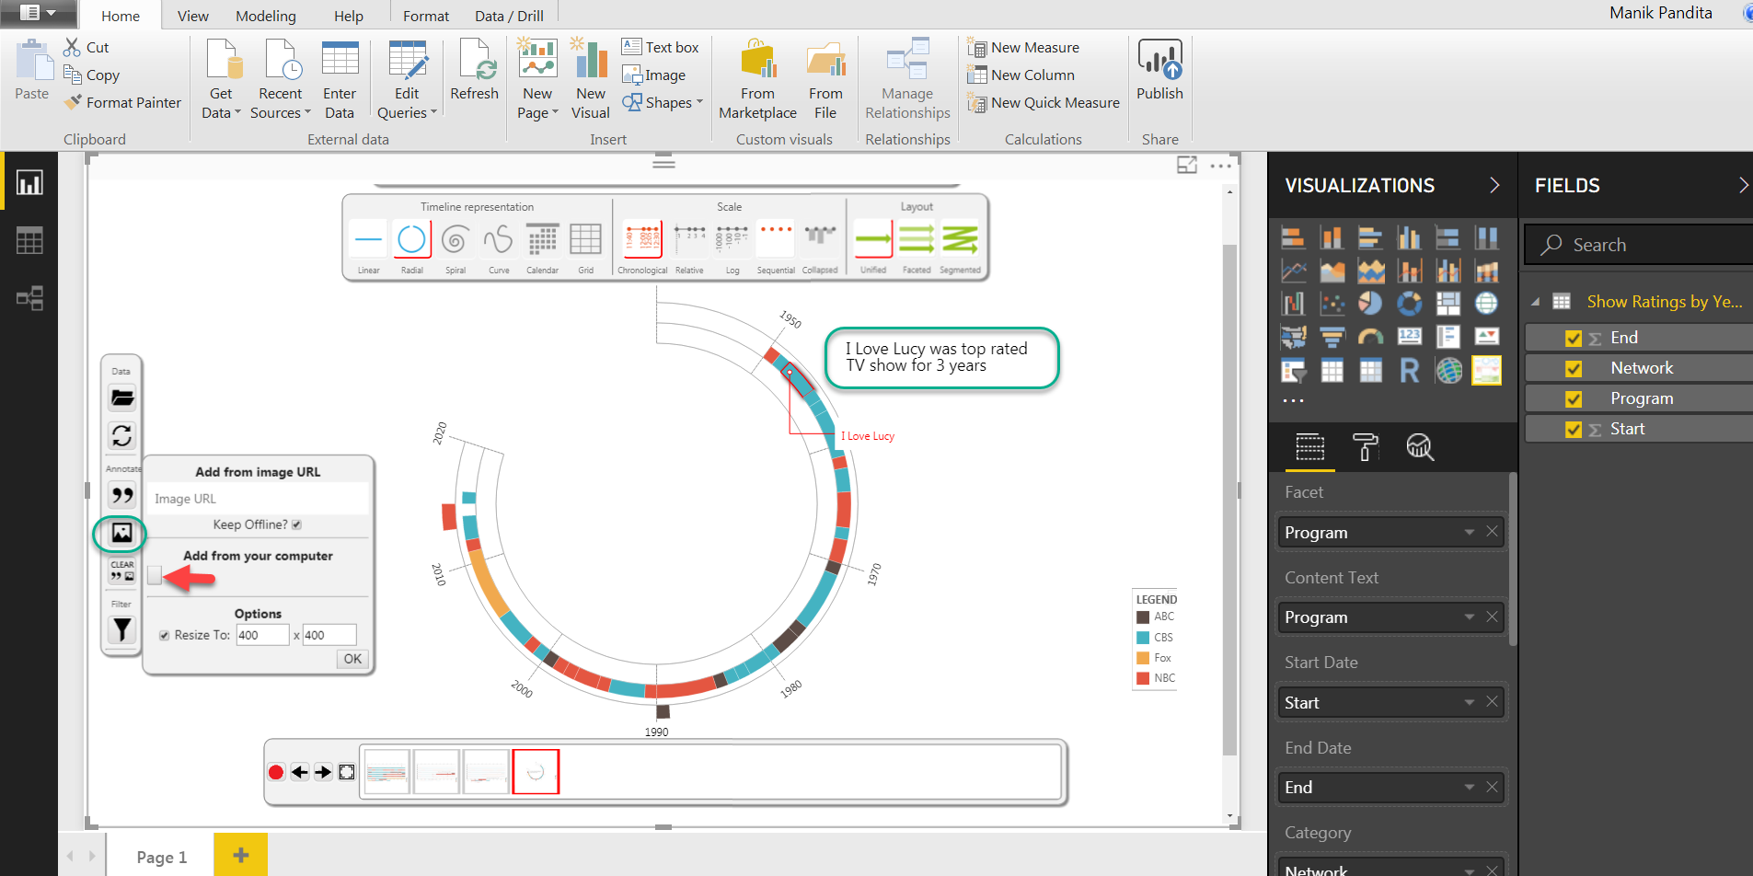

1. Click on image button to add Image to the scene. Also click on the red button to record the scene.

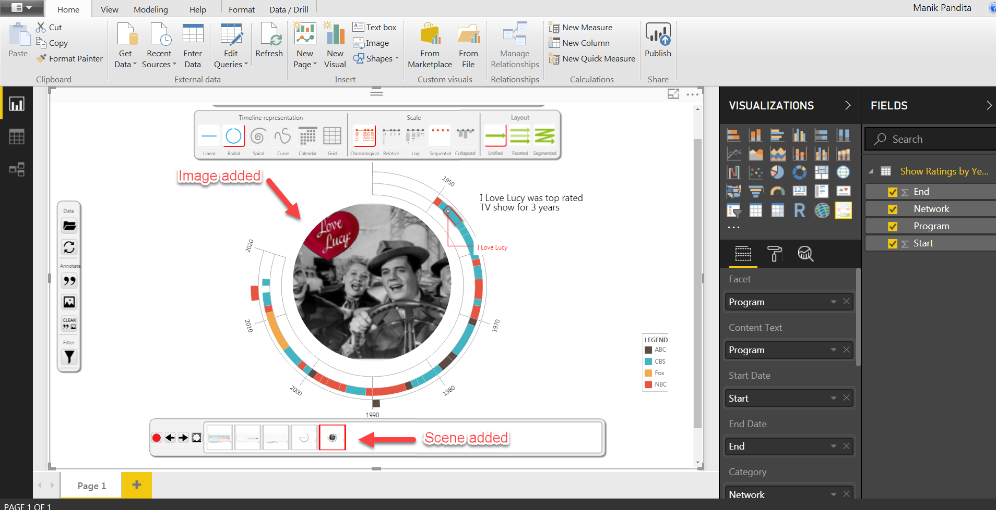

1. Repeat the step for both The Cosby Show and American Idol as shown in the below screenshots. Remember to record scenes after each scene.

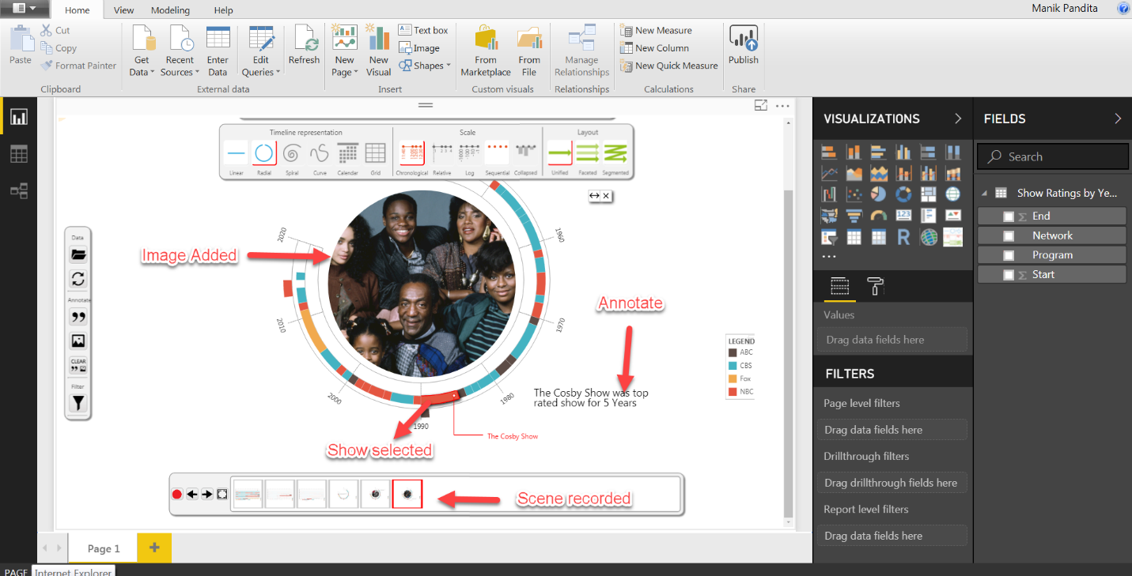

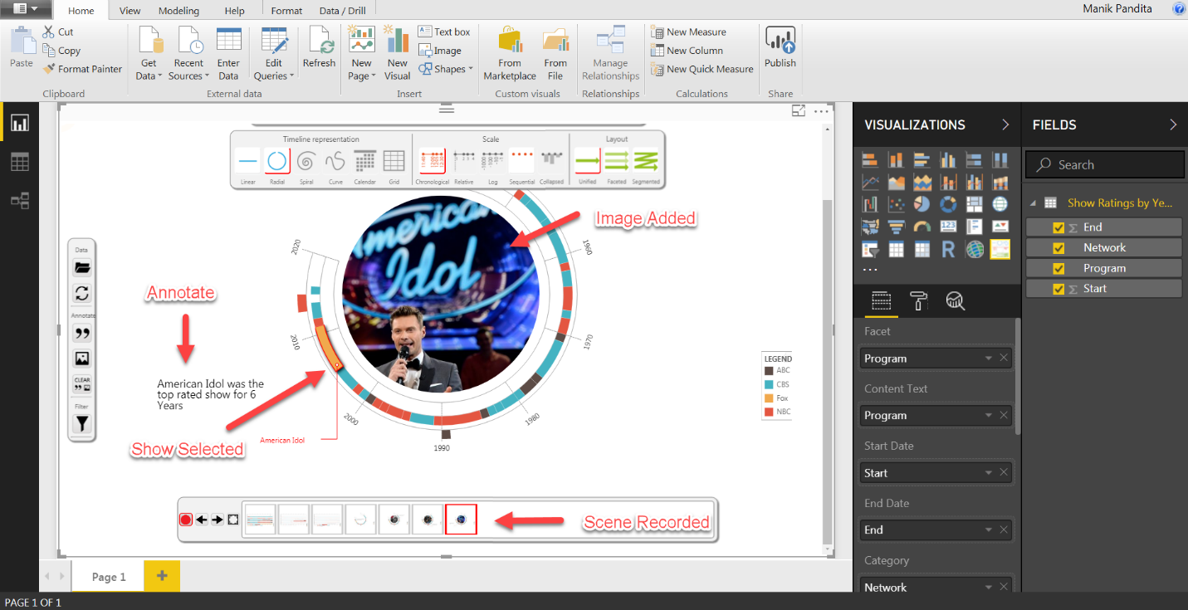

1. You can now publish or share the story with others, the arrows will be used to move to the previous and the next scene. Screenshot below for reference.

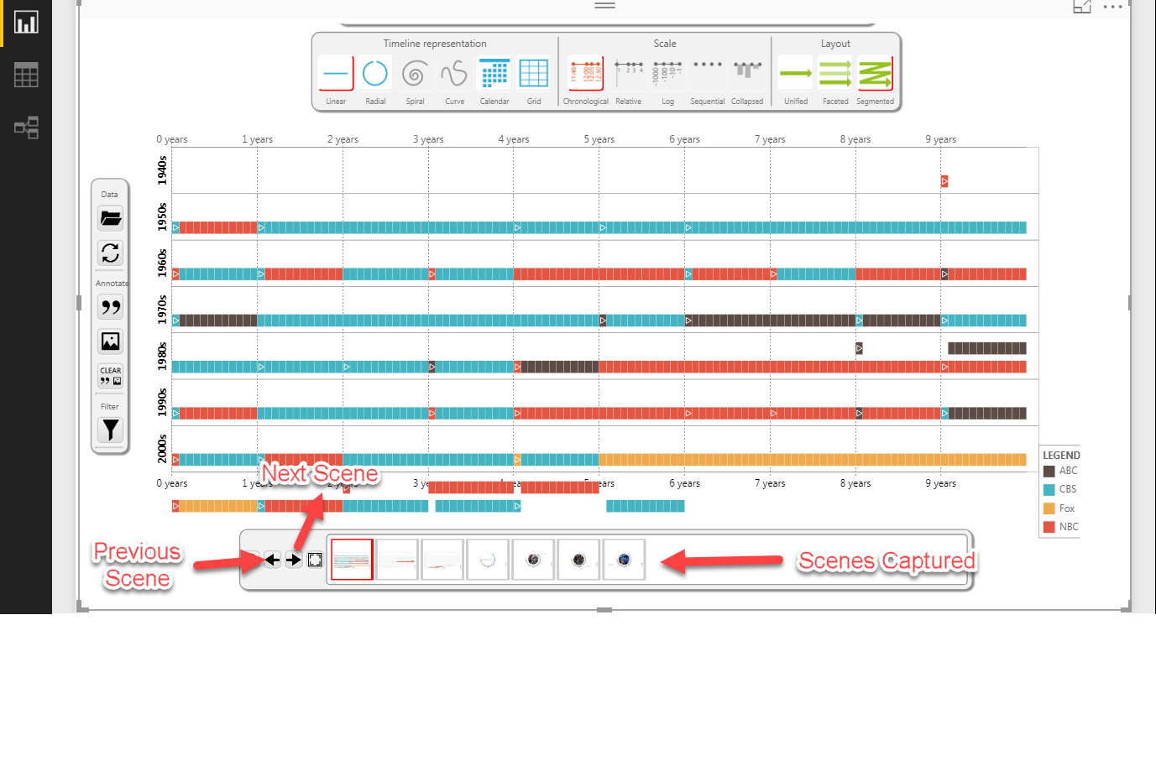

**Summary**  
  
In this exercise, we have learnt

1. How to create data stories in Power BI.
2. Use of Annotate, image, filter, timeline representation, scale, layout etc. in timeline storyteller visual.